**1. Displays the average price of all books and label the column as “Average Price”.**

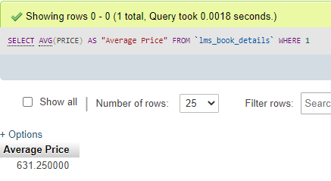

**2. Display the number of books with 6th edition**

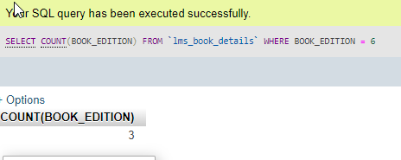

**3. List the code, title and author of a book with highest price.**

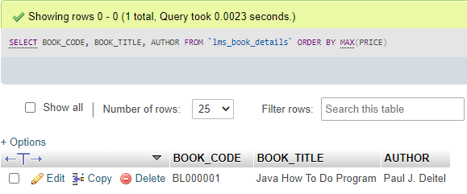

**4. Write a query that list the name and the number of books of each author. (Hint: Use book code column to determine the number of books.)**

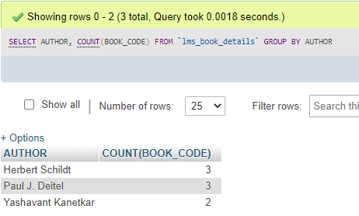

**5. Make a query to list the issue date and number of books issued on that date and display only those dates on which more than one book is issued.**

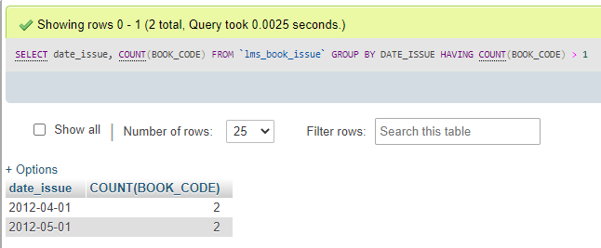

**6. Generate a query that lists the returned date and number of books returned on that date and label the column as “No of Books Returned on same date”. Sort the result in ascending order.**

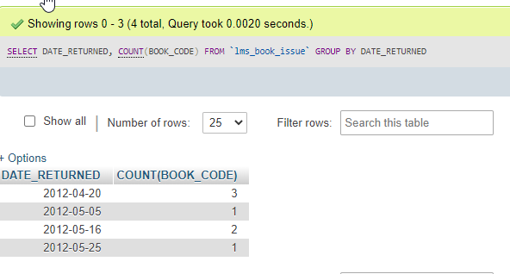

**7. Calculate the average of fine amount from the table fine details and label the column as “Average Amount”.**

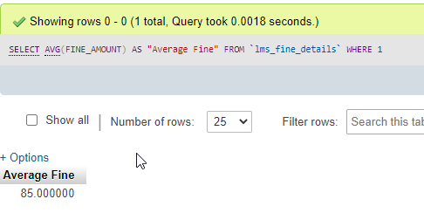

**8. List the id and the number of books supplied by supplier and display only those suppliers who has supplied more than two books.**

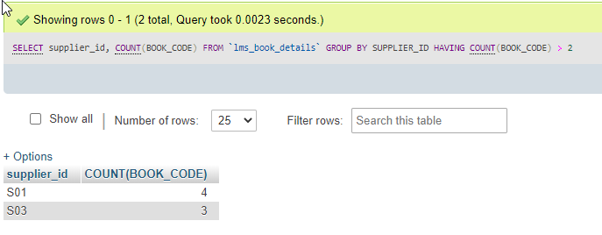

**9. List the book category and maximum price of each category. Order the result in descending order.**

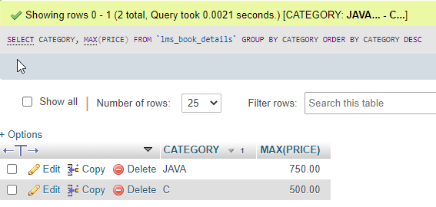

**10. Write a query that displays the publisher name and the number of books published by that publisher, list only those who have published exactly 3 books.**

